oh God Of all, at this time of our gradual awakening to the dangers we are imposing on our beautiful earth, open the hearts and minds of all your children, that we may learn to nurture rather than destroy our planet. Amen  lorraine r. schmitz | - NCUUCc  - •  - Newsletter
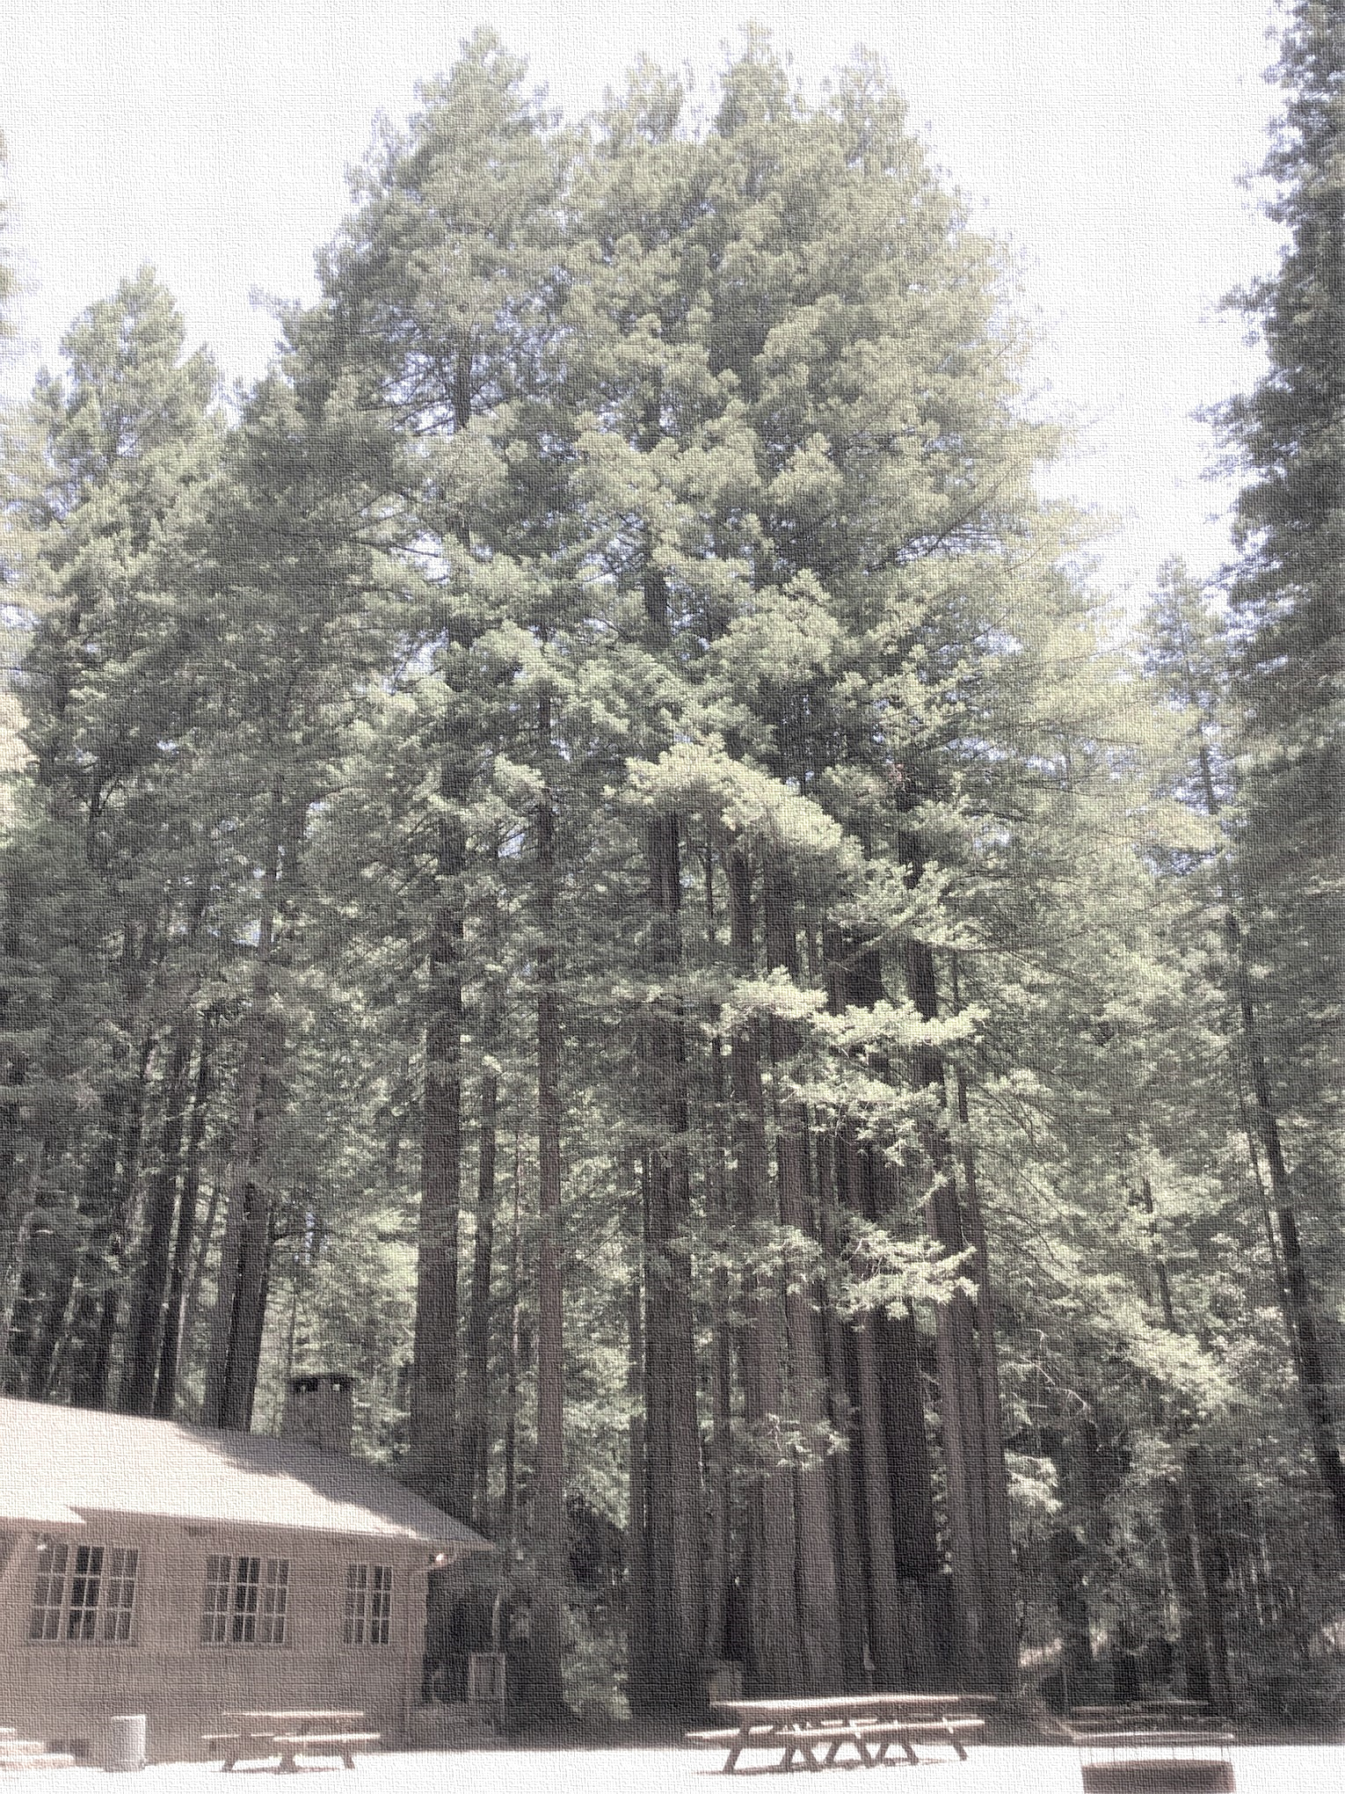  Labor Day Camp is On!  Registration is now OPEN  Welcome back Campers!!  Due to the recent rise in Covid-19 cases we regret that we can only invite campers ages 12 and older who are fully vaccinated and can provide proof of vaccination.  We will gather in community Friday September 3rd through Monday September 6th. We are planning a relaxed camp with some workshops which will include; sing-a-longs, hikes, beading, puzzles & games, archery, and whatever else YOU want to bring. So bring your favorite activity or craft to share.  Let’s get back to our Beloved Redwoods.  Deans: Marty Hoffman, martyjhoffman@gmail.com  & Fennel Schubert, Fennel.t.schubert@gmail.com  Contact Marty or Fen with workshop questions.  Registrar: Deeana McLemore, deeanamc@yahoo.com  You will not be officially registered until your vaccine is verified.  Vaccine Check: Wade Leschyn, wadel@belmateo.net  When registering, please send vaccine verifications to Wade.  Head Chief: Debby Leschyn, dleschyn@gmail.com  Contact Debby to be a part of the Kitchen Crew. | 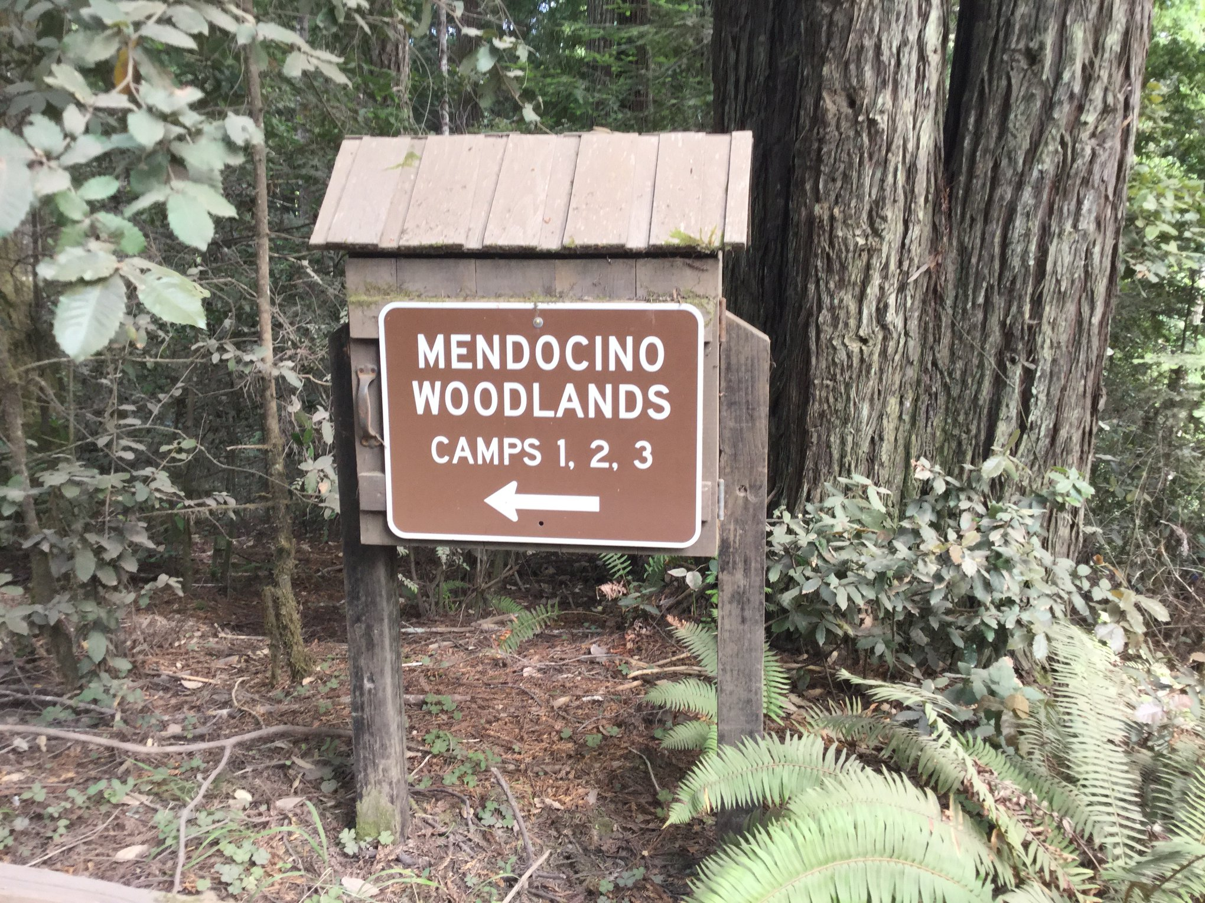  Timber Harvest  Plan Lawsuit Action  The NCUUCC Board voted unanimously to sign on as a plaintiff with EPIC in the pending lawsuit against the Timber Plan. Please go to the EPIC web page here for more information on the action. Please donate if you can.

